

INDIA MSME LANDSCAPE

District-Level Registration Trends & Analytics

A Comprehensive Analytical Report

Prepared using NDAP Open Data | May 2026

1. Project Overview
This Power BI project provides a comprehensive analytical view of India's Micro, Small and Medium Enterprise (MSME) sector is the backbone of its economy, contributing significantly to GDP, employment and inclusive growth. This report presents a comprehensive district-level analysis of MSME registration data sourced from the National Data and Analytics Platform (NDAP), covering 781 districts across 36 States and Union Territories as of Calendar Year 2026.

As of the reference date (03-May-2026), India has recorded 48.53 million MSME registrations, overwhelmingly dominated by micro enterprises (98.8%). Maharashtra leads all states with 7.52 million registrations, while Pune district tops the district rankings with over 1.11 million MSMEs. The data reveals pronounced geographic and size-based concentration, offering critical insights for policy targeting, resource allocation, and economic development planning.

2. Objectives of the Dashboard
The primary objectives of the dashboards are:
Objective 1: Map the District-Level MSME Ecosystem Across India
To create a granular, district-wise profile of MSME registrations across all 36 States and Union Territories of India, capturing the full spectrum of enterprise sizes — Micro, Small and Medium — thereby enabling a precise understanding of where formal entrepreneurship is concentrated and where significant gaps exist in economic formalisation.
Objective 2: Analyse Size-Wise Distribution and Structural Composition
To examine the enterprise size mix (Micro vs Small vs Medium) at both state and district levels, identifying the structural imbalances that characterise India's MSME sector. This objective aims to quantify the dominance of micro enterprises and assess the progression pathways from micro to small and medium scale as indicators of enterprise maturity and economic sophistication.

Objective 3: Correlate MSME Density with Population and Land Area

To investigate the relationship between district-level MSME registrations and key demographic variables including total population, urban-rural split, gender composition, and geographical land area. Understanding these correlations helps determine whether MSME growth is driven by population density, urbanisation, available land for industrial activity, or a combination of socio-economic factors.

Objective 4: Identify High-Performing and Underserved Regions for Policy Targeting

To benchmark districts and states against national averages to classify them into performance tiers — identifying both high-performing entrepreneurial hubs that can serve as models and chronically underserved regions that require targeted government intervention through schemes like PM Vishwakarma, PMEGP, and Credit Guarantee Trust Fund for Micro and Small Enterprises (CGTMSE) to accelerate MSME formation.

3. Data Sources
The dashboards are developed using structured datasets containing:
- State and District-wise MSME registration data
- Population statistics
- Rural and urban household data
- Land area distribution

Main Tables Used
- NDAP_REPORT
- source_data
- Key Table

3.1 Data Modelling:
The Power BI data model for this report is built on three interconnected tables linked via a star schema. Below is the data model diagram as configured in the Power BI Model View:
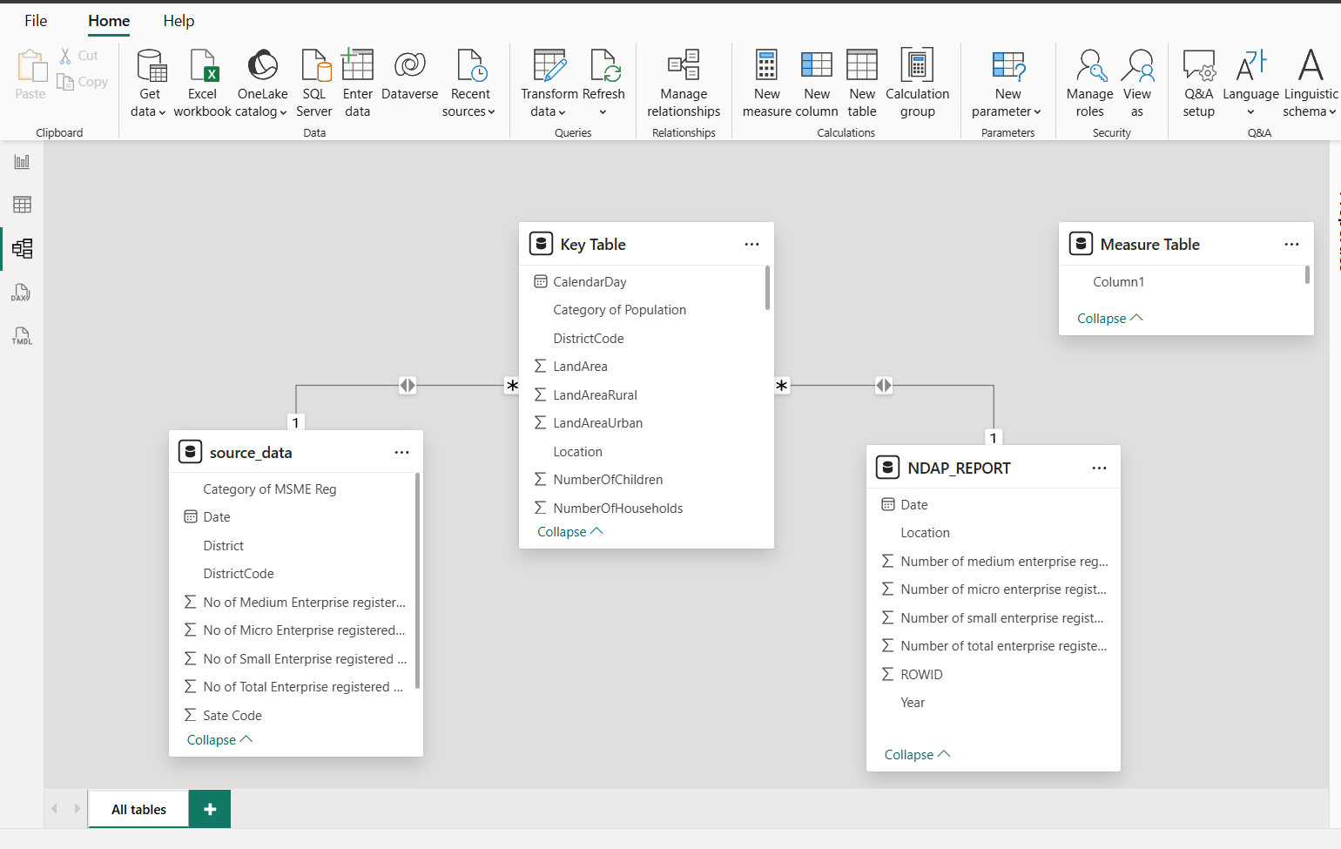

4. PAGES OVERVIEW | Power BI Dashboard

Page 1: Cleaned Data
The first page of the Power BI report functions as the data foundation layer, presenting the structured and cleaned tabular view of MSME registrations. It includes State Code and District-level filters enabling drill-down exploration. This page shows the raw counts for Micro, Small, Medium, and Total enterprise registrations at the district granularity across all 36 States and UTs. It serves as the validation layer to ensure data integrity before visual analytics are applied.

Page 2: India MSME Landscape (Main Dashboard)
The primary analytical page presenting a multi-visual dashboard titled 'India MSME Landscape: District-level Registration Trends & Analytics'. It contains seven interconnected visuals:
Visual | Chart Type | Insight Provided
District-wise Total MSME Registered | Horizontal Bar chart | Top districts by absolute MSME count with district-population correlation
District-wise Total MSME Registered | Scatter Plot | Population vs. MSME count relationship — reveals outliers and high-density clusters
Micro Vs Small Vs Medium | Stacked Bar / Progress Bars | Breakdown of 49M total: 48M Micro, 1M Small, ~0.1M Medium
Total MSME by State (Trend) | Line + Scatter (Area) | State-level MSME trajectory showing increase, decrease and net total
Count of MSME by State | Tree map | Proportional representation — UP, Maharashtra, Tamil Nadu dominates
Total MSME Reg based on Population | Donut Chart | MSME registrations as % of total population (4% MSME vs 96% non-registered)
Gender-wise MSME Registered | Donut Chart | Male vs Female population correlation with MSME registration (53.4% vs 46.6%)
Population & Land Area-wise MSME | Multi-line Area Chart | State-wise interplay between land area, total population and MSME density

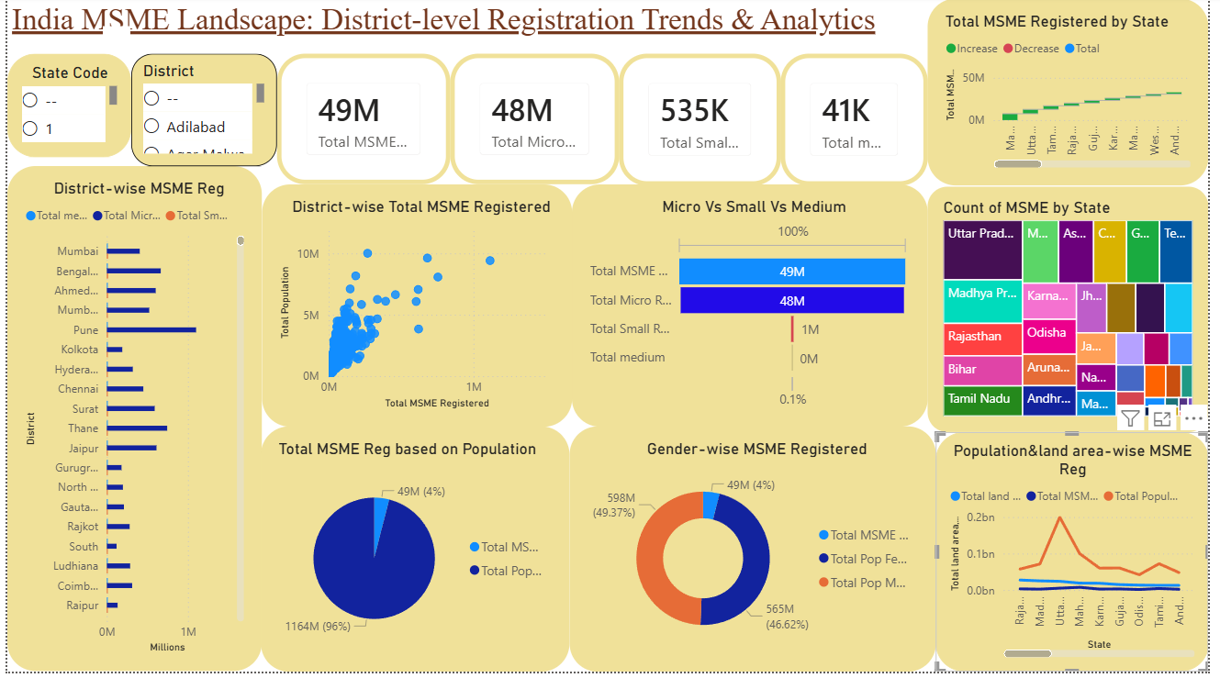

5. DESCRIPTIVE ANALYSIS | What Happened — The Number

5.1 National MSME Overview
48.53M  100%  Total Enterprises | 47.95M  98.81%  Micro Enterprises | 5,35,404  1.10%  Small Enterprises | 41,349  0.09%  Medium Enterprises
As of 03 May 2026, India's Udyam and MSME portal has recorded a total of 48,530,219 enterprise registrations across 781 districts in 36 States and Union Territories. The sectoral breakdown reveals an extreme structural skew toward micro enterprises.

5.2 State-Wise Distribution

Rank | State | Micro | Small | Medium | Total MSMEs
1 | Maharashtra | 74,27,461 | 82,009 | 7,793 | 75,17,263
2 | Uttar Pradesh | 51,05,161 | 44,455 | 2,999 | 51,52,615
3 | Tamil Nadu | 42,00,421 | 42,494 | 3,148 | 42,46,063
32 | Lakshadweep | 1,576 | 9 | 1 | 1,586
33 | Ladakh | 15,260 | 78 | 4 | 15,342
34 | Andaman & Nicobar | 19,003 | 179 | 4 | 19,186
MSME registrations are heavily concentrated in a few large states. The top 5 states account for approximately 47% of all national registrations, indicating significant geographic concentration.

5.3 District-Wise Leaders

Rank | District | State | Total MSMEs
1 | Pune | Maharashtra | 11,14,867
2 | Thane | Maharashtra | 7,54,424
3 | Bengaluru (Urban) | Karnataka | 6,81,738
At the district level, urban industrial hubs dominate MSME registrations. Pune is the undisputed leader, driven by its thriving manufacturing, IT services, and automobile ancillary ecosystem.

5.4 Population & Land Context

India's 768 mapped districts carry a combined population of 1.196 billion people, with a male-female split of 51.5% and 48.5% respectively. Urban population stands at 370 million (30.9%) versus 826 million rural (69.1%). Total land area across mapped districts is approximately 245.7 million sq. km, reflecting India's vast geographic diversity.

6. DIAGNOSTIC ANALYSIS | Why It Happened — Root Causes

  - Why Does Maharashtra Lead?

Maharashtra's dominance (7.52M MSMEs, 15.5% national share) is explained by a convergence of structural advantages:
- Decades of planned industrial development through MIDCs (Maharashtra Industrial Development Corporation) created physical and institutional infrastructure enabling MSME clusters in Pune, Nasik, Aurangabad, and Thane.
- Mumbai Metropolitan Region (MMR) provides unmatched access to finance, logistics, markets, and a skilled labour pool, reducing business formation costs.
- Pune's IT and education economy and Mumbai's BFSI dominance create downstream demand for ancillary MSMEs in food, transport, retail, and professional services.
- Maharashtra's proactive implementation of Udyam registration camps and ease-of-business reforms has driven higher registration rates even among pre-existing informal enterprises.

  - Why Are Micro Enterprises 98.8% of MSMEs?

The near-total dominance of micro enterprises reveals structural bottlenecks preventing enterprise graduation:

Most micro enterprises lack collateral required for formal credit access. Without growth capital, enterprises remain trapped below the small enterprise threshold (investment > Rs 1 crore).

Micro enterprises, predominantly in traditional trades (textiles, handicrafts, food processing), lack access to technology upgradation, limiting productivity and scalability.

Inability to participate in GeM (Government e-Marketplace) tendering, export markets, or large retailer supply chains keeps micro enterprises in local, low-margin markets.

Since Udyam registration benefits (credit priority, CGTMSE, subsidies) accrue to all MSMEs regardless of size, there is no economic incentive to declare growth and cross the micro threshold, leading to intentional under-declaration.

6.3 Why Are North-Eastern States and UTs Underrepresented?

States like Lakshadweep (1,586), Ladakh (15,342), and Andaman & Nicobar (19,186) show extremely low MSME counts, explained by:

Physical remoteness drives up logistics costs, making manufacturing-based MSMEs unviable and restricting enterprise formation to basic retail and services.

Poor road, rail, and digital infrastructure raises transaction costs for enterprise registration and reduces market access for goods produced.

Low absolute population directly limits market size, reducing the economic incentive to form formal enterprises.

Absence of formal banking infrastructure in remote areas restricts access to working capital, preventing enterprise formalisation even where informal economic activity exists.

6.4 Population-MSME Correlation Diagnostic

While population generally correlates with MSME count, the scatter plot reveals important outliers. Bihar (large population, low MSME density) versus Gujarat (medium population, high MSME per capita) demonstrates that pure population size is insufficient — institutional quality, infrastructure, and state policy environment are stronger determinants of MSME formation rates.

7. PREDICTIVE ANALYSIS | What Will Happen — Forward Scenarios

7.1 National MSME Growth Trajectory

Based on existing registration trends, demographic momentum, and policy tailwinds from the Union Budget 2024-25 and 2025-26 (enhanced MSME credit guarantees, technology fund), India's MSME registrations are projected to cross 55 million by 2027 and approach 65 million by 2030, driven primarily by:

Udyam Assist Platform (UAP) targeting informal enterprises is expected to add 5-8 million new micro registrations over 2025-2030.

Rising female labour force participation, PM Vishwakarma targeting women artisans, and SHG-to-enterprise conversion programs are expected to boost women-owned MSME share from current ~20% to 30%+ by 2030.

ONDC (Open Network for Digital Commerce) integration, UPI merchant ecosystem, and GeM adoption will lower barriers for service-sector MSMEs in Tier 2 and Tier 3 cities.
Year | Projected Total MSMEs | Micro (Est.) | Small (Est.) | Medium (Est.) | Key Driver
2026 (Actual) | 48.53M | 47.95M | 5.35L | 41,349 | Udyam baseline
2027 | ~53M | ~52.1M | ~6.5L | ~50,000 | UAP formalisation
2028 | ~57M | ~55.8M | ~7.8L | ~60,000 | Women + Digital MSMEs
2029 | ~61M | ~59.2M | ~9.5L | ~73,000 | MSME graduation policy
2030 | ~65M | ~62.5M | ~11.5L | ~90,000 | USD 5T economy push

7.2 State-Level Growth Predictions

High Growth States (2026-2030): Uttar Pradesh, Madhya Pradesh, and Odisha are predicted to show above-average growth (15-20% CAGR) driven by improved connectivity (Purvanchal Expressway, MP industrial corridors) and active state MSME policies.

Stable Growth States: Maharashtra, Tamil Nadu, Gujarat will maintain steady 8-10% CAGR — growth limited by market saturation in top districts but offset by Tier 2 city expansion (Nashik, Coimbatore, Surat hinterlands).

High-Potential Emerging States: Assam, Meghalaya, and Tripura are projected to show the highest percentage growth (25-35% from low base) as Northeast connectivity via trans-border trade routes with Bangladesh and Myanmar matures.

7.3 Enterprise Size Shift Prediction

Current micro enterprise dominance (98.8%) is predicted to marginally decline to ~96% by 2030 as credit guarantee expansion, technology adoption subsidies, and market linkage programs enable graduation of 300,000-500,000 micro enterprises to small enterprise status. Medium enterprise share could double to 0.2% (from 0.09%) as formalisation of medium-scale manufacturers in auto, pharma, and electronics clusters accelerates.

8. PRESCRIPTIVE ANALYSIS | What Should Be Done — Action Roadmap

8.1 Tier 1: Immediate Interventions (0–12 Months)

Credit Guarantee Deepening in Low-MSME Districts: Identify the bottom 200 districts (< 10,000 MSMEs) and launch targeted CGTMSE camps, Mudra loan melas, and Jan Samarth portal on-boarding drives. Each district should have a dedicated MSME facilitation officer with monthly registration and credit disbursement targets.

Udyam Assist Platform (UAP) Scale-Up: Fast-track UAP deployment to North-Eastern states, J&K, Ladakh, and island territories. Establish partnership with CSCs (Common Service Centres) for assisted registration, targeting 2 million new informal-to-formal conversions by March 2027.

Gender-Disaggregated MSME Data Collection: Mandate Udyam portal to capture owner gender, SC/ST/OBC status, and sector at registration. This will enable targeted scheme design and impact measurement — a critical gap in the current dataset.

8.2 Tier 2: Medium-Term Structural Reforms (1–3 Years)

MSME Graduation Incentive Programme: Introduce tax holiday extensions, enhanced credit limits, and priority procurement quotas specifically for enterprises crossing from micro to small and small to medium thresholds. Address intentional under-declaration by making graduation economically beneficial rather than penalising.

District MSME Competitiveness Index (DMCI): Develop and publish a quarterly DMCI ranking each district on MSME density per lakh population, credit penetration, digital adoption, and formalisation rate. Use this as a conditionality for state-level MSME scheme fund release, creating competitive federalism incentives.

Cluster Development Programme Expansion: Scale the existing SFURTI (Scheme of Fund for Regeneration of Traditional Industries) and CDP (Cluster Development Programme) to cover 500 new clusters in underperforming districts, focusing on agro-processing, handloom, handicrafts, and rural manufacturing in Bihar, UP, Jharkhand, and Odisha.

8.3 Tier 3: Long-Term Ecosystem Building (3–5 Years)

Technology Adoption Mission for MSMEs: Launch a dedicated MSME Technology Adoption Mission with Rs 5,000 crore corpus, providing 50% capital subsidy for machinery, ERP software, quality certification (ISO, BIS), and e-commerce integration. This target breaking the productivity trap of micro enterprises.

Regional MSME Equity Equalisation: Implement a weighted fiscal transfer mechanism where states with below-average MSME density (< 3,000 per lakh population) receive additional Union allocations for industrial corridor development, MSME parks, and broadband connectivity — directly addressing the spatial inequality revealed by this dataset.

Priority Action | Target States/Districts | Expected Impact | Timeline
UAP Formalisation Camps | NE States, J&K, UTs | +2M registrations | 0-12 months
CGTMSE Bottom-200 Drive | Bihar, UP, Odisha districts | +Rs 50,000 Cr credit | 0-18 months
Gender Data Mandate | National (Udyam portal) | Policy targeting enabled | 0-6 months
Graduation Incentive Scheme | All states | +3L micro→small upgrade | 12-36 months
DMCI Ranking System | 36 States/UTs | Competitive federalism | 12-24 months
Tech Adoption Mission | Top 300 MSME districts | +25% productivity | 24-60 months
Regional Equity Fund | 10 low-density states | Spatial rebalancing | 36-60 months

9. KEY INSIGHTS | Data-Driven Findings

Insight 1: India's MSME Base is Predominantly Informal-to-Formal Migrants

The near-total dominance of micro enterprises (98.8%) signals that Udyam registration is capturing predominantly informal economic units transitioning to the formal economy — not the creation of new businesses. This is structurally positive (formalisation brings these enterprises into the tax, credit, and social security net) but masks the actual rate of new enterprise creation, which is likely far lower.

Insight 2: Western India Outperforms on MSME Density Adjusted for Population

Maharashtra and Gujarat together account for 10.6M MSMEs from a combined population of ~240 million — a density of ~44 MSMEs per 1,000 population, against the national average of ~39. This western corridor's industrial heritage, port connectivity, and business-friendly regulatory environment create a self-reinforcing entrepreneurship ecosystem that is difficult to replicate without sustained structural investment.

Insight 3: Urbanisation is a Strong but Non-Deterministic Driver

The scatter plot analysis shows that urban districts consistently outperform rural ones in MSME count, but the relationship is not linear. Several large rural districts in Tamil Nadu, Punjab, and Haryana show MSME densities competitive with urban centres, driven by agro-processing, dairy, and cottage industry clusters — indicating that rural MSMEs can thrive when supported by appropriate value chain infrastructure.

Insight 4: The North-East Remains India's Largest MSME Opportunity

The eight North-Eastern states collectively account for less than 1% of national MSME registrations despite comprising 8% of India's land area. As ASEAN connectivity through the Act East Policy matures and border trade with Myanmar, Bhutan, and Bangladesh expands, these states represent the highest-potential under-exploited MSME frontier in India over the next decade.

Insight 5: Gender Parity in MSME Ownership Requires Direct Intervention

With women comprising 48.5% of India's population but estimated to own only 20-25% of MSMEs, gender-based entrepreneurship exclusion is a systemic issue. The absence of gender-disaggregated data in the current NDAP dataset itself reveals how undervalued women's economic participation data collection remains — a gap that must be urgently addressed for evidence-based policy.

Insight 6: Medium Enterprise Scarcity Signals a 'Missing Middle'

Medium enterprises (0.09% of total) represent the critical 'missing middle' of India's enterprise ecosystem — the class of enterprises that typically drive export competitiveness, technology adoption, and quality jobs. Their scarcity reflects both the difficulty of MSME graduation and the disincentives created by threshold-based policy design that makes crossing size thresholds costly.

10. CONCLUSION | Summary & Call to Action
India's MSME sector, with 48.53 million registrations across 781 districts, reflects both remarkable progress and persistent gaps. While states like Maharashtra and Gujarat lead with dense entrepreneurial ecosystems, vast regions in eastern and north-eastern India remain underserved. Micro enterprises dominate at 98.8%, signalling strong formalisation but weak graduation pathways.
Moving forward, three priorities stand out: closing the geographic gap, enabling enterprises to scale beyond micro, and using data like NDAP to guide smarter policy. With coordinated action across Centre and States, the MSME sector can truly power India's journey to a USD 5 trillion economy.

—— End of Report ——
Prepared using NDAP Open Data (Dataset 7723) | India MSME Landscape | May 2026

